使用 STM32 开发心电监测仪

尚硅谷研究院

版本: V1.0

1. 项目需求即技术选型

1. 心电监测仪项目架构图

* 1. 硬件架构图

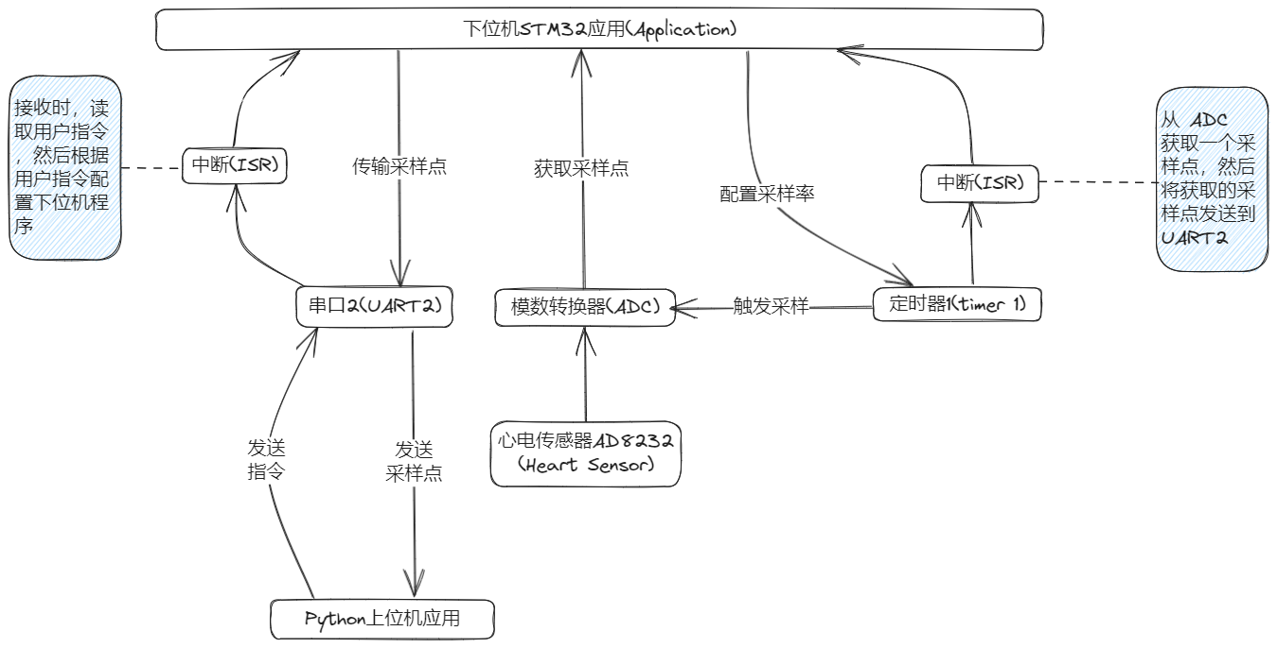

* 1. 软件架构图

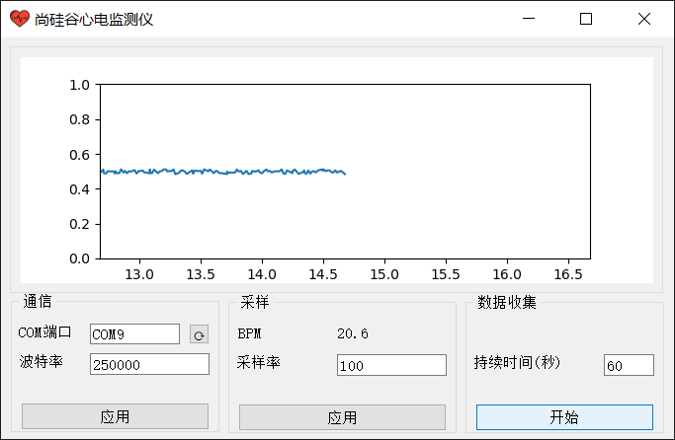

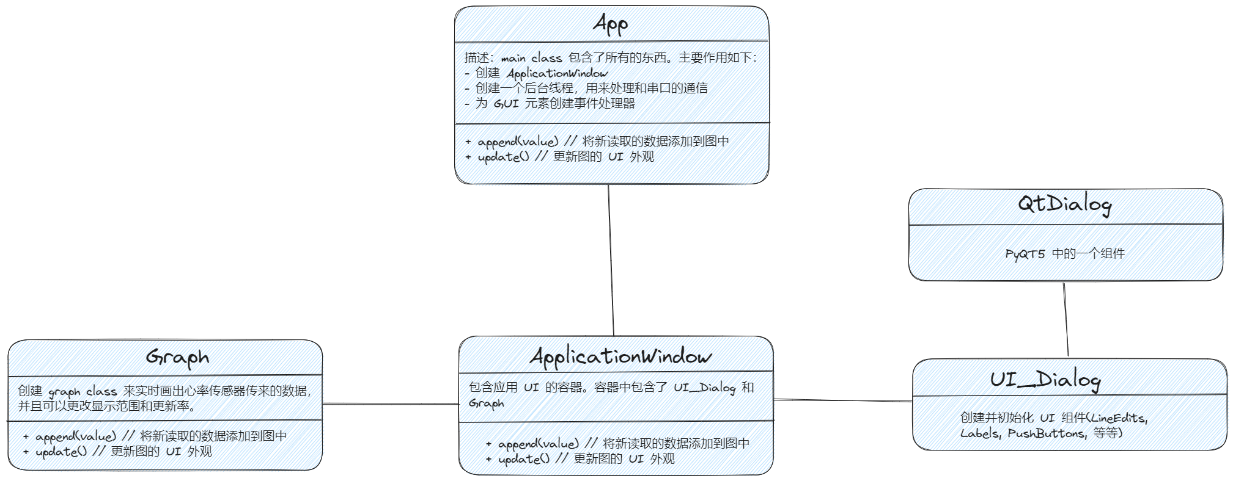

1. 构建开发工具链

传统的 STM32 开发工具一般使用 Keil MDK-ARM IDE 来进行。但 Keil IDE 的编码体验不是很好（只支持 Windows 平台，代码高亮和不全都不好，经常误报错误和警告）。所以我们自己搭建一套开发体验（代码补全，高亮，提示，代码格式化等等）丝滑的工具链。选用的工具如下：

* STM32CubeMX：用来产生包含了 ST 官方 HAL 库的样板代码。非常的方便，基本上是开发 STM32 单片机程序的必备工具。[下载链接](https://www.st.com/zh/development-tools/stm32cubemx.html#overview)
* Clion：JetBrains 公司提供的 C++ IDE。[下载链接](https://www.jetbrains.com/clion/)
* openocd：开源的单片机程序烧写工具。[下载链接](https://gnutoolchains.com/arm-eabi/openocd/)。下载完解压之后，注意将 bin 文件夹的绝对路径添加到环境变量中。打开 PowerShell ，然后输入 openocd -v 确认安装成功。
* gcc-arm-none-eabi：开源的 ARM 指令集编译器。[下载链接](https://developer.arm.com/-/media/Files/downloads/gnu-rm/10.3-2021.10/gcc-arm-none-eabi-10.3-2021.10-win32.exe?rev=29bb46cfa0434fbda93abb33c1d480e6&hash=B2C5AAE07841929A0D0BF460896D6E52)。安装完之后，找到安装路径。然后将 bin 文件夹的绝对路径添加到环境变量中。打开 PowerShell ，然后输入 arm-none-eabi-gcc.exe -v 确认安装成功。
* Anaconda：Python集成工具包。用来编写 PC 端的上位机程序。[下载链接](https://www.anaconda.com/download)

1. 使用 STM32CubeMX 创建 STM32F103 项目
2. 打开 STM32CubeMX

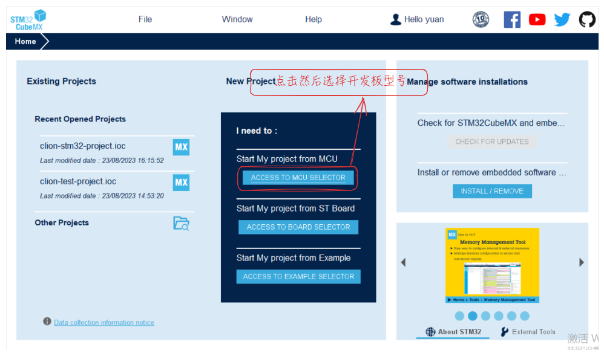

1. 选择要使用的芯片

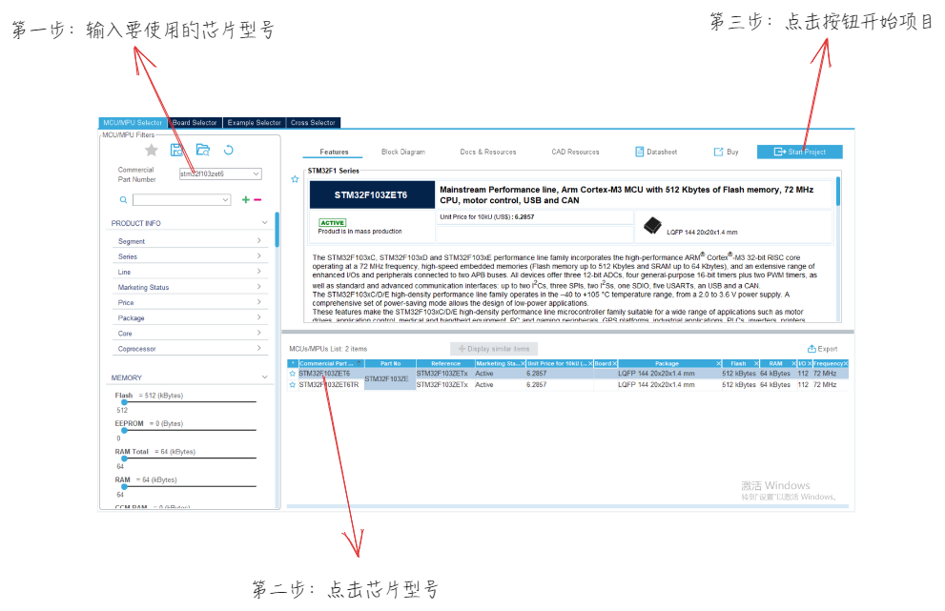

1. 配置 STM32 的系统设置以及一些外设

首先设置单片机的时钟源。

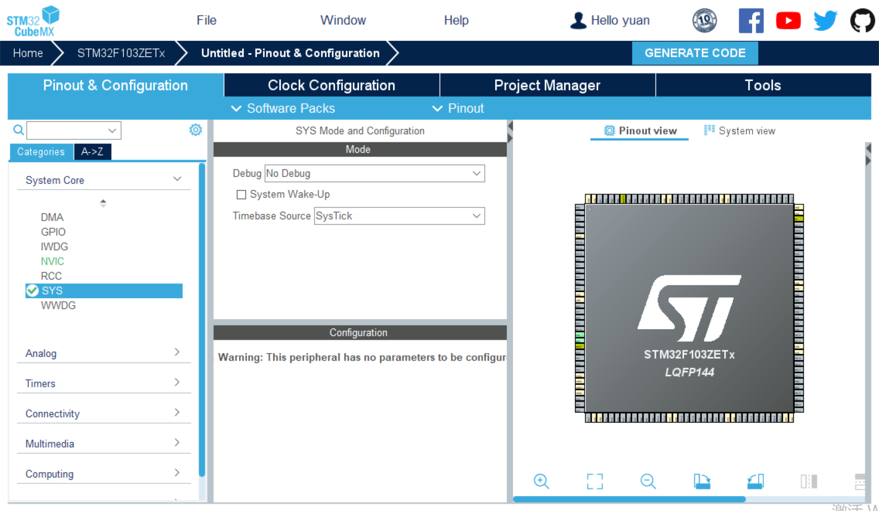

Timebase Source 我们选择 SysTick 。

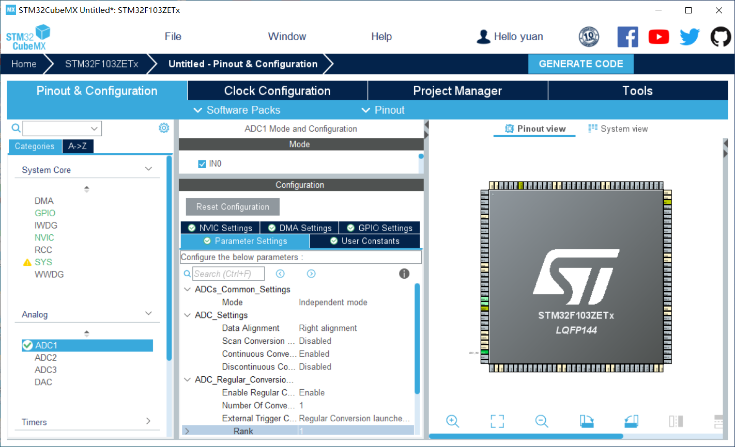

接下来我们设置模数转换器相关功能，我们选择 STM32 自带的 ADC1 的第 0 个通道 IN0 。

Parameter Settings 如图所示。

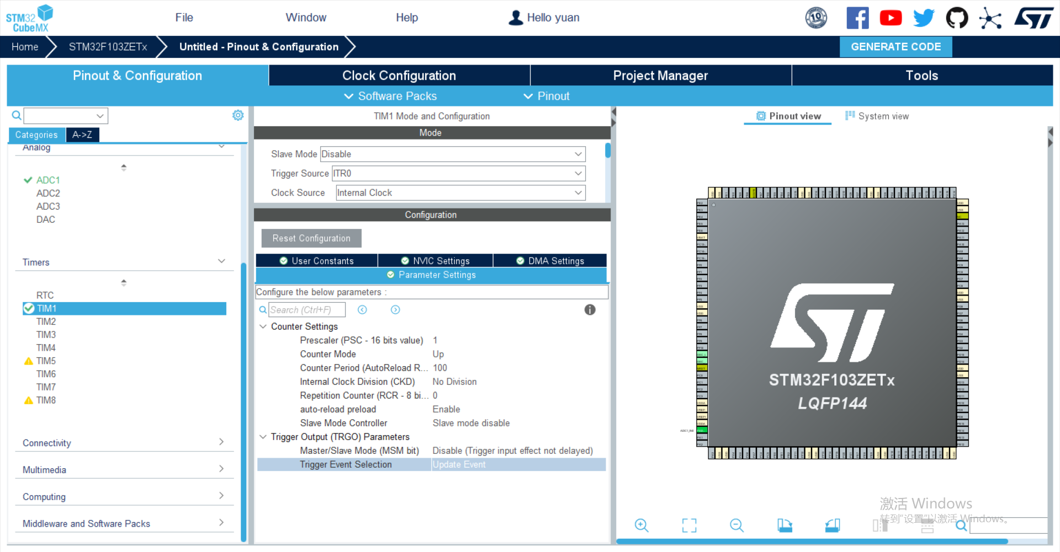

接下来我们配置定时器，我们选用 STM32 提供的定时器1，也就是 TIM1 。

参数设置如图所示。

接下来我们配置串口通信相关功能，我们使用 STM32 的 USART2 串口。

打开中断，并将波特率设置为 250000 。

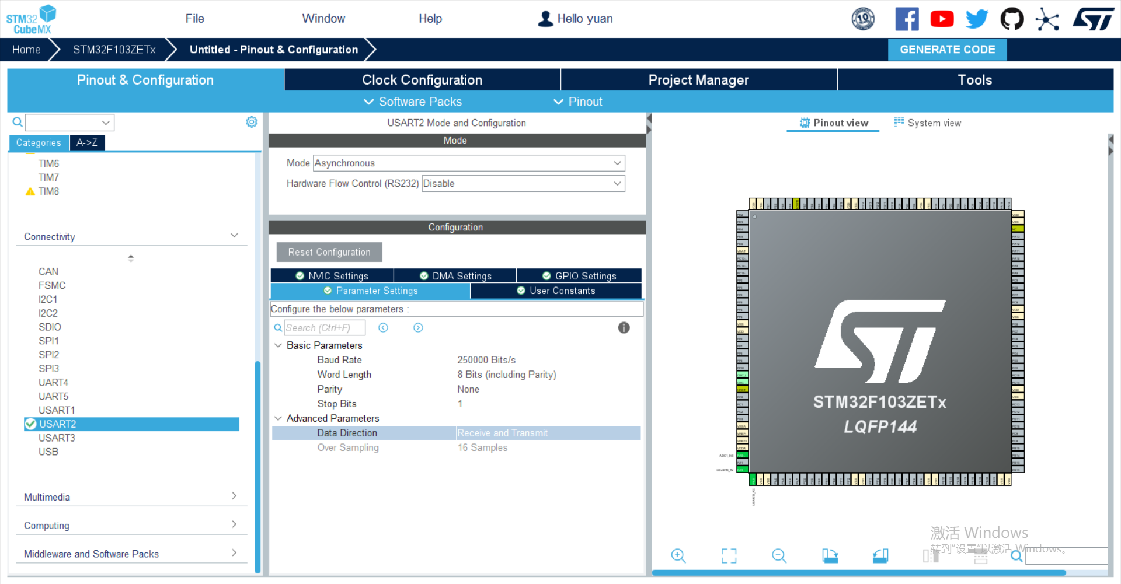

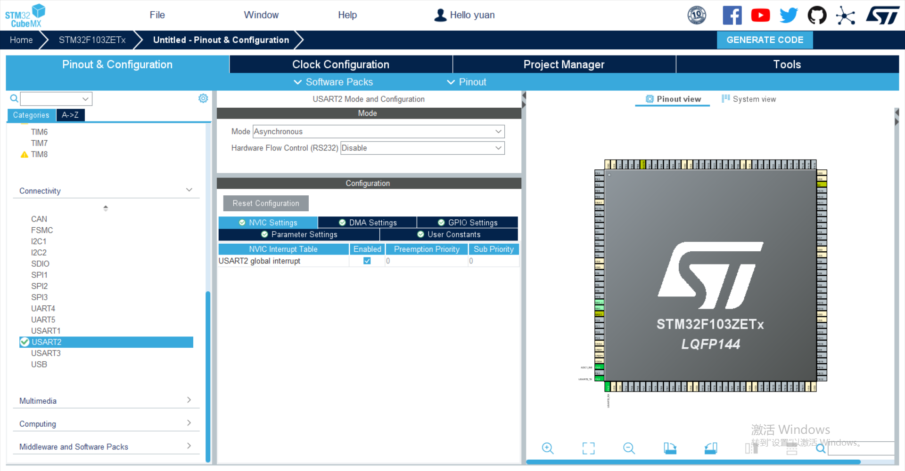

然后将相关的 GPIO PIN 打开并设置 PIN 的各种特性（输入，输出等）。

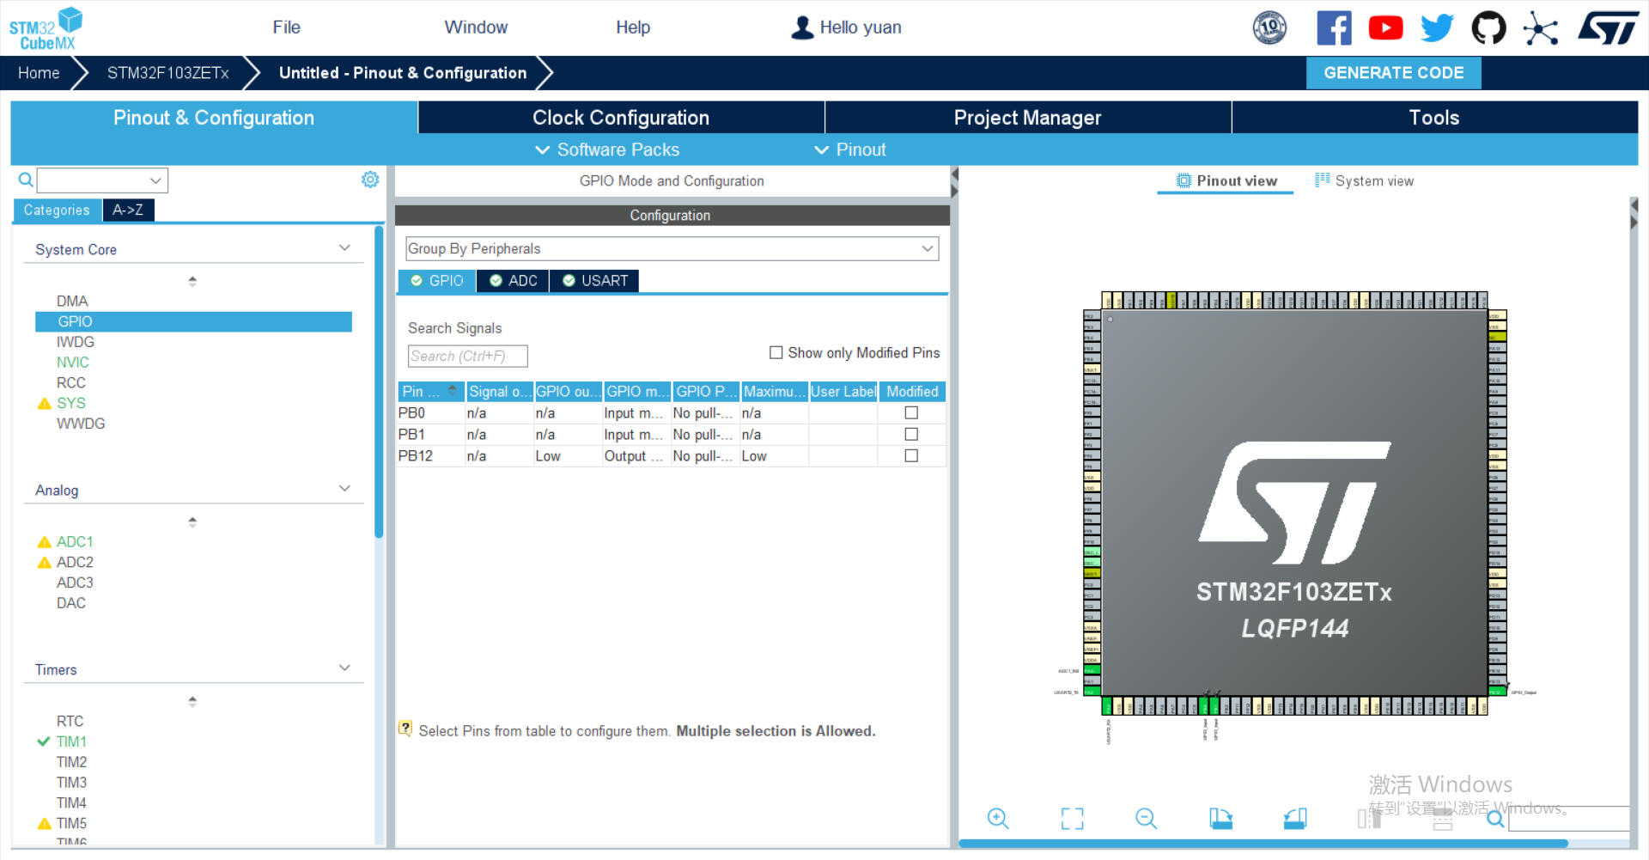

最后我们配置 STM32 的时钟树。

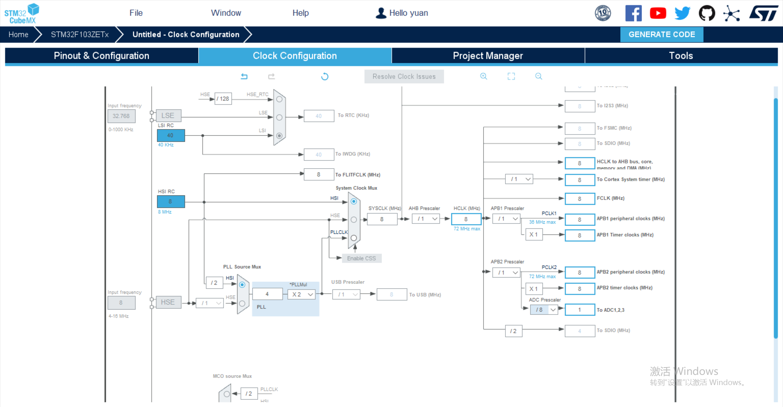

主要是将 ADC Prescaler 设置为 /8 。

1. 创建项目

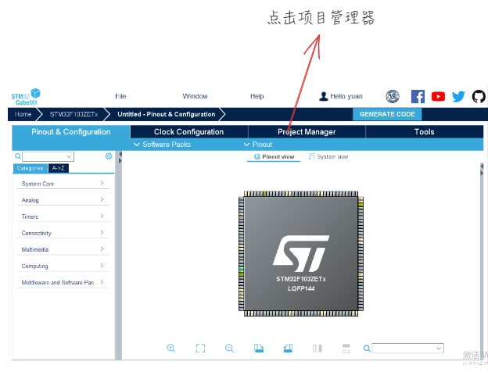

然后输入项目名称，并创建项目

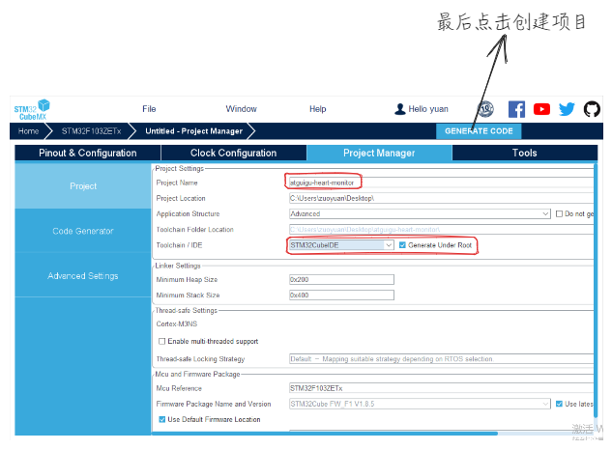

1. 关闭 STM32CubeMX

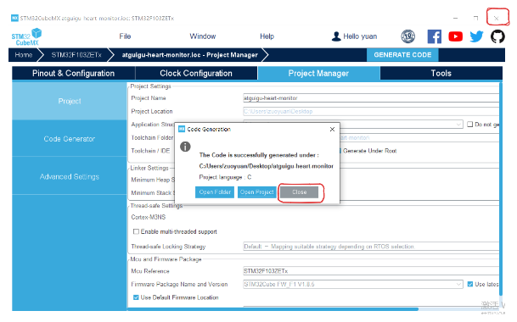

1. 编写烧写工具配置文件

我们使用的仿真器是 cmsis-dap 协议的仿真器。

在路径 解压openocd的绝对路径\openocd-20230712\OpenOCD-20230712-0.12.0\share\openocd\scripts\board 文件夹中新建文件 stm32f1discovery.cfg 文件，在里面写入以下内容：

source [find interface/cmsis-dap.cfg]  
  
transport select swd  
  
# 待烧写单片机是 stm32f1x 型号  
source [find target/stm32f1x.cfg]  
  
# 设置调试器,最大速度为24MHz  
adapter speed 12000

1. 使用 Clion 打开 STM32CubeMX 创建的项目

使用 Clion 打开创建的项目中的 .ioc 文件，注意要 **作为项目打开** 。

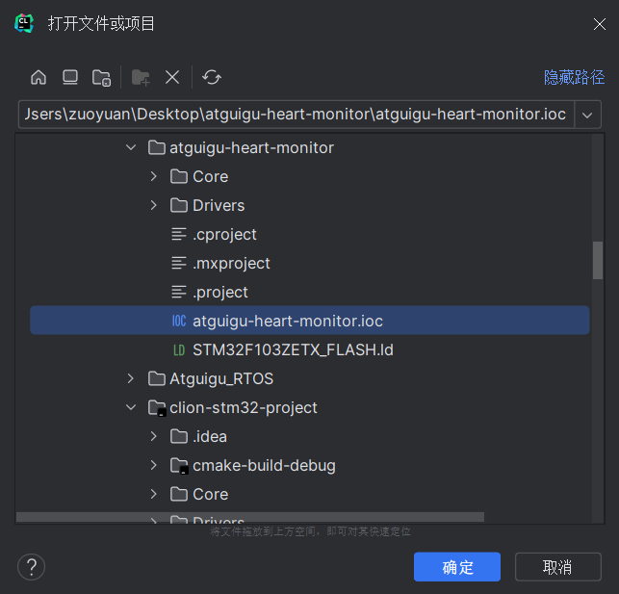

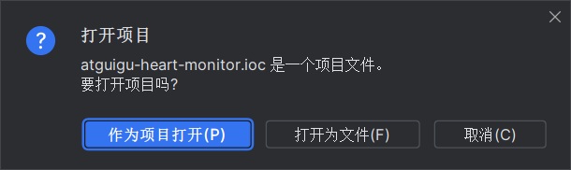

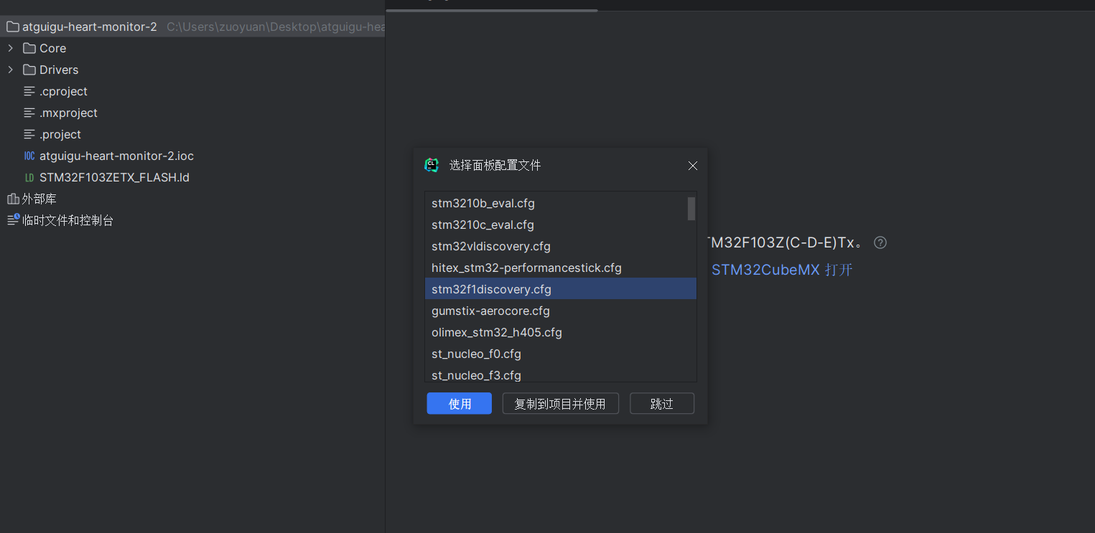

此时会弹出选择 openocd 配置文件的面板，选择 stm32f1discovery.cfg 。

还有两个特别重要的地方需要配置，也就是 openocd 、编译工具链 的配置。

首先检查一下 openocd 和 stm32cubemx 的路径是否正确。

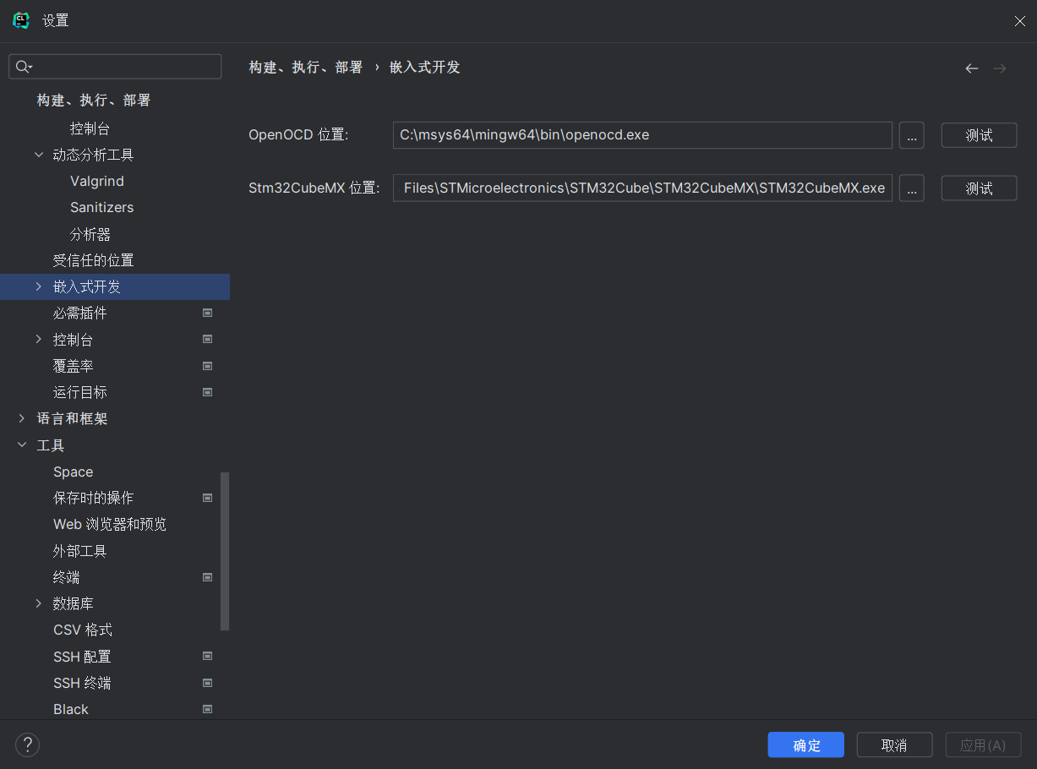

然后新建一个名为 **系统** 的工具链，主要要确保 arm-none-eabi-gcc 和 arm-none-eabi-g++ 的路径是正确的。

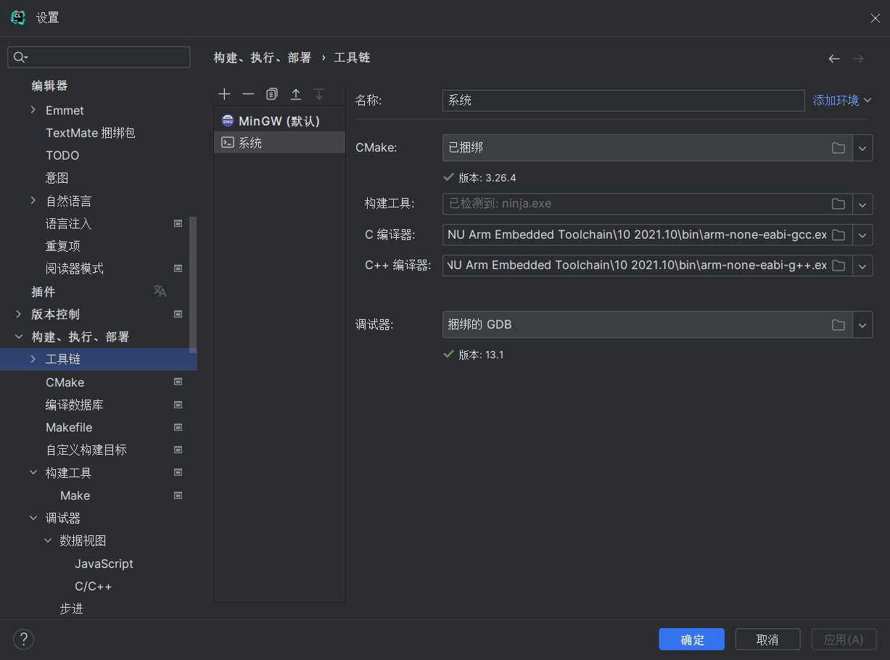

最后将 CMake 选项卡的工具链设置为 **系统** 。

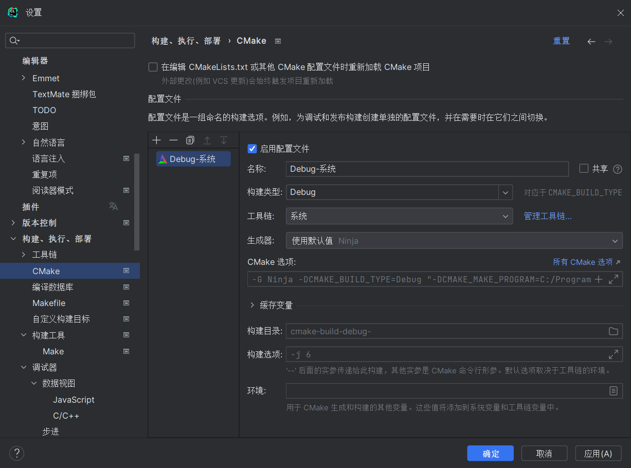

然后就可以愉快的写代码了。点击运行看一下样板代码是否可以烧写成功。

1. 心电监测仪项目代码编写

* 1. 下位机代码编写

根据我们的一系列配置，stm32cubemx 帮助我们生成了大部分代码，如果有某些配置我们设置错了，可以直接在代码中改动。接下来我们将要写的代码去掉注释，贴在下面，可以和自动生成的代码对比，我们修改了哪些内容。

我们首先编写初始化 STM32 各种外设的代码。stm32f1xx_hal_msp.c 代码内容如下：

#include "main.h"  
  
void HAL_MspInit(void) {  
 __HAL_RCC_AFIO_CLK_ENABLE();  
 __HAL_RCC_PWR_CLK_ENABLE();  
  
 __HAL_AFIO_REMAP_SWJ_NOJTAG();  
}  
  
void HAL_ADC_MspInit(ADC_HandleTypeDef *hadc) {  
 GPIO_InitTypeDef GPIO_InitStruct = {0};  
 if (hadc->Instance == ADC1) {  
 /* Peripheral clock enable */  
 __HAL_RCC_ADC1_CLK_ENABLE();  
 __HAL_RCC_GPIOA_CLK_ENABLE();  
 /**ADC1 GPIO Configuration  
 PA0-WKUP ------> ADC1_IN0  
 */  
 GPIO_InitStruct.Pin = GPIO_PIN_0;  
 GPIO_InitStruct.Mode = GPIO_MODE_ANALOG;  
 HAL_GPIO_Init(GPIOA, &GPIO_InitStruct);  
  
 HAL_NVIC_SetPriority(ADC1_2_IRQn, 0, 0);  
 HAL_NVIC_EnableIRQ(ADC1_2_IRQn);  
 }  
}  
  
void HAL_ADC_MspDeInit(ADC_HandleTypeDef *hadc) {  
 if (hadc->Instance == ADC1) {  
 __HAL_RCC_ADC1_CLK_DISABLE();  
 HAL_GPIO_DeInit(GPIOA, GPIO_PIN_0);  
 HAL_NVIC_DisableIRQ(ADC1_2_IRQn);  
 }  
}  
  
void HAL_TIM_Base_MspInit(TIM_HandleTypeDef *htim_base) {  
 if (htim_base->Instance == TIM1) {  
 __HAL_RCC_TIM1_CLK_ENABLE();  
 HAL_NVIC_SetPriority(TIM1_UP_IRQn, 0, 0);  
 HAL_NVIC_EnableIRQ(TIM1_UP_IRQn);  
 }  
}  
  
void HAL_TIM_Base_MspDeInit(TIM_HandleTypeDef *htim_base) {  
 if (htim_base->Instance == TIM1) {  
 __HAL_RCC_TIM1_CLK_DISABLE();  
 HAL_NVIC_DisableIRQ(TIM1_UP_IRQn);  
 }  
}  
  
void HAL_UART_MspInit(UART_HandleTypeDef *huart) {  
 GPIO_InitTypeDef GPIO_InitStruct = {0};  
 if (huart->Instance == USART2) {  
 __HAL_RCC_USART2_CLK_ENABLE();  
  
 __HAL_RCC_GPIOA_CLK_ENABLE();  
 /**USART2 GPIO Configuration  
 PA2 ------> USART2_TX  
 PA3 ------> USART2_RX  
 */  
 GPIO_InitStruct.Pin = GPIO_PIN_2;  
 GPIO_InitStruct.Mode = GPIO_MODE_AF_PP;  
 GPIO_InitStruct.Speed = GPIO_SPEED_FREQ_HIGH;  
 HAL_GPIO_Init(GPIOA, &GPIO_InitStruct);  
  
 GPIO_InitStruct.Pin = GPIO_PIN_3;  
 GPIO_InitStruct.Mode = GPIO_MODE_INPUT;  
 GPIO_InitStruct.Pull = GPIO_NOPULL;  
 HAL_GPIO_Init(GPIOA, &GPIO_InitStruct);  
  
 /* USART2 interrupt Init */  
 HAL_NVIC_SetPriority(USART2_IRQn, 0, 0);  
 HAL_NVIC_EnableIRQ(USART2_IRQn);  
 }  
}  
  
void HAL_UART_MspDeInit(UART_HandleTypeDef *huart) {  
 if (huart->Instance == USART2) {  
 __HAL_RCC_USART2_CLK_DISABLE();  
  
 /**USART2 GPIO Configuration  
 PA2 ------> USART2_TX  
 PA3 ------> USART2_RX  
 */  
 HAL_GPIO_DeInit(GPIOA, GPIO_PIN_2 | GPIO_PIN_3);  
  
 HAL_NVIC_DisableIRQ(USART2_IRQn);  
 }  
}

然后编写中断函数的代码，代码文件为 stm32f1xx_it.c ，内容如下：

#include "main.h"  
#include "stm32f1xx_it.h"  
  
extern ADC_HandleTypeDef hadc1;  
extern TIM_HandleTypeDef htim1;  
extern UART_HandleTypeDef huart2;  
  
void NMI_Handler(void) {  
}  
  
void HardFault_Handler(void) {  
 while (1) {  
 }  
}  
  
void MemManage_Handler(void) {  
 while (1) {  
 }  
}  
  
void BusFault_Handler(void) {  
 while (1) {  
 }  
}  
  
void UsageFault_Handler(void) {  
 while (1) {  
 }  
}  
  
void SVC_Handler(void) {  
}  
  
void DebugMon_Handler(void) {  
}  
  
void PendSV_Handler(void) {  
}  
  
// 外设中断  
void ADC1_2_IRQHandler(void) {  
 HAL_ADC_IRQHandler(&hadc1);  
}

最后我们编写 main.c 文件，里面包含了业务逻辑的代码。

#include "main.h"  
#include "string.h"  
#include "stdlib.h"  
#include "stdio.h"  
  
ADC_HandleTypeDef hadc1;  
  
TIM_HandleTypeDef htim1;  
  
UART_HandleTypeDef huart2;  
  
void SystemClock_Config(void);  
  
static void MX_GPIO_Init(void);  
  
static void MX_ADC1_Init(void);  
  
static void MX_TIM1_Init(void);  
  
static void MX_USART2_UART_Init(void);  
  
  
// 全局变量的定义  
uint32_t sample;  
char TxBuffer[8];  
char param_s[7];  
int param;  
char RxBuffer[8];  
int RxIndex = 0;  
char c;  
  
int ticks = 0;  
int isSending = 0;  
int duration = 0;  
int takeSample = 0;  
int command_flag = 0;  
  
// 系统时钟频率我们使用的是：8MHz  
void configureSamplingRate(int sampling_rate) {  
 volatile int prescaler = 128 / sampling_rate + 1;  
 volatile int load = 8388608 / (sampling_rate * prescaler);  
 __HAL_TIM_SET_PRESCALER(&htim1, prescaler);  
 __HAL_TIM_SET_AUTORELOAD(&htim1, load);  
}  
  
void TIM1_UP_IRQHandler() {  
 HAL_TIM_IRQHandler(&htim1);  
 if (!isSending) return;  
 else if (ticks > 1000 * duration) {  
 ticks = 0;  
 isSending = 0;  
 }  
 takeSample = 1;  
}  
  
void SysTick_Handler(void) {  
 HAL_IncTick();  
 if (isSending) ticks++;  
}  
  
void USART2_IRQHandler(void) {  
 HAL_UART_IRQHandler(&huart2);  
 int result = HAL_UART_Receive(&huart2, (uint8_t *) &c, 1, 500);  
 if (result == HAL_OK) {  
 if (c != 0x0A)  
 RxBuffer[RxIndex++] = c;  
 else  
 command_flag = 1;  
 }  
}  
  
void process_command() {  
 __HAL_UART_DISABLE_IT(&huart2, UART_IT_RXNE);  
 strcpy(param_s, RxBuffer + 1);  
 param = atoi(param_s);  
 char command = RxBuffer[0];  
 __HAL_UART_ENABLE_IT(&huart2, UART_IT_RXNE);  
 switch (command) {  
 case 's':  
 configureSamplingRate(param);  
 break;  
 case 'c':  
 isSending = 1;  
 duration = param;  
 break;  
 default:  
 break;  
 }  
 memset(RxBuffer, 0, 8);  
 RxIndex = 0;  
}  
  
int main(void) {  
 HAL_Init();  
  
 SystemClock_Config();  
  
 HAL_SYSTICK_Config(8192);  
  
 MX_GPIO_Init();  
 MX_ADC1_Init();  
 MX_TIM1_Init();  
 MX_USART2_UART_Init();  
  
 HAL_TIM_Base_Start_IT(&htim1);  
 configureSamplingRate(100);  
 HAL_ADC_Start(&hadc1);  
  
 __HAL_UART_ENABLE_IT(&huart2, UART_IT_RXNE);  
  
 while (1) {  
 if (takeSample) {  
 HAL_TIM_Base_Stop_IT(&htim1);  
 takeSample = 0;  
 HAL_TIM_Base_Start_IT(&htim1);  
 sample = HAL_ADC_GetValue(&hadc1);  
 sprintf(TxBuffer, "%04lu\n", (unsigned long) sample);  
 HAL_UART_Transmit(&huart2, (uint8_t *) TxBuffer, sizeof(TxBuffer), HAL_MAX_DELAY);  
 }  
 if (command_flag) {  
 process_command();  
 command_flag = 0;  
 }  
 if (!isSending) {  
 HAL_GPIO_WritePin(GPIOB, GPIO_PIN_12, 1); //turn off  
 HAL_TIM_Base_Stop(&htim1);  
 HAL_ADC_Stop(&hadc1);  
 HAL_SuspendTick();  
 HAL_PWR_EnterSLEEPMode(PWR_LOWPOWERREGULATOR_ON, PWR_SLEEPENTRY_WFI);  
 HAL_ResumeTick();  
 SystemClock_Config();  
 HAL_TIM_Base_Start(&htim1);  
 HAL_ADC_Start(&hadc1);  
 HAL_GPIO_WritePin(GPIOB, GPIO_PIN_12, 0); //turn on  
 }  
 }  
}  
  
/**  
 * @brief System Clock Configuration  
 * @retval None  
 */  
void SystemClock_Config(void) {  
 RCC_OscInitTypeDef RCC_OscInitStruct = {0};  
 RCC_ClkInitTypeDef RCC_ClkInitStruct = {0};  
 RCC_PeriphCLKInitTypeDef PeriphClkInit = {0};  
  
 /** Initializes the RCC Oscillators according to the specified parameters  
 * in the RCC_OscInitTypeDef structure.  
 */  
 RCC_OscInitStruct.OscillatorType = RCC_OSCILLATORTYPE_HSI;  
 RCC_OscInitStruct.HSIState = RCC_HSI_ON;  
 RCC_OscInitStruct.HSICalibrationValue = RCC_HSICALIBRATION_DEFAULT;  
 RCC_OscInitStruct.PLL.PLLState = RCC_PLL_NONE;  
 if (HAL_RCC_OscConfig(&RCC_OscInitStruct) != HAL_OK) {  
 Error_Handler();  
 }  
  
 /** Initializes the CPU, AHB and APB buses clocks  
 */  
 RCC_ClkInitStruct.ClockType = RCC_CLOCKTYPE_HCLK | RCC_CLOCKTYPE_SYSCLK  
 | RCC_CLOCKTYPE_PCLK1 | RCC_CLOCKTYPE_PCLK2;  
 RCC_ClkInitStruct.SYSCLKSource = RCC_SYSCLKSOURCE_HSI;  
 RCC_ClkInitStruct.AHBCLKDivider = RCC_SYSCLK_DIV1;  
 RCC_ClkInitStruct.APB1CLKDivider = RCC_HCLK_DIV1;  
 RCC_ClkInitStruct.APB2CLKDivider = RCC_HCLK_DIV1;  
  
 if (HAL_RCC_ClockConfig(&RCC_ClkInitStruct, FLASH_LATENCY_0) != HAL_OK) {  
 Error_Handler();  
 }  
 PeriphClkInit.PeriphClockSelection = RCC_PERIPHCLK_ADC;  
 PeriphClkInit.AdcClockSelection = RCC_ADCPCLK2_DIV8;  
 if (HAL_RCCEx_PeriphCLKConfig(&PeriphClkInit) != HAL_OK) {  
 Error_Handler();  
 }  
}  
  
/**  
 * @brief ADC1 Initialization Function  
 * @param None  
 * @retval None  
 */  
static void MX_ADC1_Init(void) {  
 ADC_ChannelConfTypeDef sConfig = {0};  
  
 /** Common config  
 */  
 hadc1.Instance = ADC1;  
 hadc1.Init.ScanConvMode = ADC_SCAN_DISABLE;  
 hadc1.Init.ContinuousConvMode = ENABLE;  
 hadc1.Init.DiscontinuousConvMode = DISABLE;  
 hadc1.Init.ExternalTrigConv = ADC_SOFTWARE_START;  
 hadc1.Init.DataAlign = ADC_DATAALIGN_RIGHT;  
 hadc1.Init.NbrOfConversion = 1;  
 if (HAL_ADC_Init(&hadc1) != HAL_OK) {  
 Error_Handler();  
 }  
  
 /** Configure Regular Channel  
 */  
 sConfig.Channel = ADC_CHANNEL_0;  
 sConfig.Rank = ADC_REGULAR_RANK_1;  
 sConfig.SamplingTime = ADC_SAMPLETIME_1CYCLE_5;  
 if (HAL_ADC_ConfigChannel(&hadc1, &sConfig) != HAL_OK) {  
 Error_Handler();  
 }  
}  
  
/**  
 * @brief TIM1 Initialization Function  
 * @param None  
 * @retval None  
 */  
static void MX_TIM1_Init(void) {  
 TIM_ClockConfigTypeDef sClockSourceConfig = {0};  
 TIM_MasterConfigTypeDef sMasterConfig = {0};  
  
 htim1.Instance = TIM1;  
 htim1.Init.Prescaler = 1;  
 htim1.Init.CounterMode = TIM_COUNTERMODE_UP;  
 htim1.Init.Period = 100;  
 htim1.Init.ClockDivision = TIM_CLOCKDIVISION_DIV1;  
 htim1.Init.RepetitionCounter = 0;  
 htim1.Init.AutoReloadPreload = TIM_AUTORELOAD_PRELOAD_ENABLE;  
 if (HAL_TIM_Base_Init(&htim1) != HAL_OK) {  
 Error_Handler();  
 }  
 sClockSourceConfig.ClockSource = TIM_CLOCKSOURCE_INTERNAL;  
 if (HAL_TIM_ConfigClockSource(&htim1, &sClockSourceConfig) != HAL_OK) {  
 Error_Handler();  
 }  
  
 sMasterConfig.MasterOutputTrigger = TIM_TRGO_RESET;  
 sMasterConfig.MasterSlaveMode = TIM_MASTERSLAVEMODE_DISABLE;  
 if (HAL_TIMEx_MasterConfigSynchronization(&htim1, &sMasterConfig) != HAL_OK) {  
 Error_Handler();  
 }  
}  
  
/**  
 * @brief USART2 Initialization Function  
 * @param None  
 * @retval None  
 */  
static void MX_USART2_UART_Init(void) {  
 huart2.Instance = USART2;  
 huart2.Init.BaudRate = 250000;  
 huart2.Init.WordLength = UART_WORDLENGTH_8B;  
 huart2.Init.StopBits = UART_STOPBITS_1;  
 huart2.Init.Parity = UART_PARITY_NONE;  
 huart2.Init.Mode = UART_MODE_TX_RX;  
 huart2.Init.HwFlowCtl = UART_HWCONTROL_NONE;  
 huart2.Init.OverSampling = UART_OVERSAMPLING_16;  
 if (HAL_UART_Init(&huart2) != HAL_OK) {  
 Error_Handler();  
 }  
}  
  
/**  
 * @brief GPIO Initialization Function  
 * @param None  
 * @retval None  
 */  
static void MX_GPIO_Init(void) {  
 GPIO_InitTypeDef GPIO_InitStruct = {0};  
  
 /* GPIO Ports Clock Enable */  
 __HAL_RCC_GPIOB_CLK_ENABLE();  
  
 /*Configure GPIO pin Output Level */  
 HAL_GPIO_WritePin(GPIOB, GPIO_PIN_12, GPIO_PIN_RESET);  
  
 /*Configure GPIO pins : PB0 PB1 */  
 GPIO_InitStruct.Pin = GPIO_PIN_0 | GPIO_PIN_1;  
 GPIO_InitStruct.Mode = GPIO_MODE_INPUT;  
 GPIO_InitStruct.Pull = GPIO_NOPULL;  
 HAL_GPIO_Init(GPIOB, &GPIO_InitStruct);  
  
 /*Configure GPIO pin : PB12 */  
 GPIO_InitStruct.Pin = GPIO_PIN_12;  
 GPIO_InitStruct.Mode = GPIO_MODE_OUTPUT_PP;  
 GPIO_InitStruct.Pull = GPIO_NOPULL;  
 GPIO_InitStruct.Speed = GPIO_SPEED_FREQ_LOW;  
 HAL_GPIO_Init(GPIOB, &GPIO_InitStruct);  
}  
  
/**  
 * @brief This function is executed in case of error occurrence.  
 * @retval None  
 */  
void Error_Handler(void) {  
}

* 1. 上位机代码编写

首先打开 Anaconda PowerShell Prompt 程序，然后在终端中输入

pip install pyserial

安装 Python 的串口程序包。然后就可以写代码了。

首先编写 ui.py

# -*- coding: utf-8 -*-  
  
# Form implementation generated from reading ui file 'design.ui'  
#  
# Created by: PyQt5 UI code generator 5.14.2  
#  
# WARNING! All changes made in this file will be lost!  
  
  
from PyQt5 import QtCore, QtGui, QtWidgets  
  
  
class Ui_Dialog(object):  
 def setupUi(self, Dialog):  
 Dialog.setObjectName("Dialog")  
 Dialog.resize(681, 407)  
 icon = QtGui.QIcon()  
 icon.addPixmap(QtGui.QPixmap("icon.ico"),  
 QtGui.QIcon.Normal, QtGui.QIcon.Off)  
 Dialog.setWindowIcon(icon)  
 self.communicationGroupBox = QtWidgets.QGroupBox(Dialog)  
 self.communicationGroupBox.setGeometry(QtCore.QRect(10, 260, 211, 141))  
 self.communicationGroupBox.setObjectName("communicationGroupBox")  
 self.portLineEdit = QtWidgets.QLineEdit(self.communicationGroupBox)  
 self.portLineEdit.setGeometry(QtCore.QRect(80, 30, 91, 21))  
 self.portLineEdit.setObjectName("portLineEdit")  
 self.portRefreshButton = QtWidgets.QPushButton(  
 self.communicationGroupBox)  
 self.portRefreshButton.setGeometry(QtCore.QRect(180, 30, 21, 21))  
 self.portRefreshButton.setObjectName("portRefreshButton")  
 self.portLabel = QtWidgets.QLabel(self.communicationGroupBox)  
 self.portLabel.setGeometry(QtCore.QRect(8, 30, 55, 16))  
 self.portLabel.setObjectName("portLabel")  
 self.communicationApplyButton = QtWidgets.QPushButton(  
 self.communicationGroupBox)  
 self.communicationApplyButton.setGeometry(  
 QtCore.QRect(10, 110, 191, 28))  
 self.communicationApplyButton.setObjectName("communicationApplyButton")  
 self.baudRateLineEdit = QtWidgets.QLineEdit(self.communicationGroupBox)  
 self.baudRateLineEdit.setGeometry(QtCore.QRect(80, 60, 121, 22))  
 self.baudRateLineEdit.setObjectName("baudRateLineEdit")  
 self.baudRateLineEdit.setText("250000")  
 self.baudRateLabel = QtWidgets.QLabel(self.communicationGroupBox)  
 self.baudRateLabel.setGeometry(QtCore.QRect(8, 60, 61, 16))  
 self.baudRateLabel.setObjectName("baudRateLabel")  
 self.communicationErrorLabel = QtWidgets.QLabel(  
 self.communicationGroupBox)  
 self.communicationErrorLabel.setGeometry(QtCore.QRect(10, 90, 191, 16))  
 self.communicationErrorLabel.setText("")  
 self.communicationErrorLabel.setObjectName("communicationErrorLabel")  
 self.communicationErrorLabel.setStyleSheet(  
 'QLabel#communicationErrorLabel {color: red}')  
 self.samplingGroupBox = QtWidgets.QGroupBox(Dialog)  
 self.samplingGroupBox.setGeometry(QtCore.QRect(230, 261, 231, 141))  
 self.samplingGroupBox.setObjectName("samplingGroupBox")  
 self.samplingRateLineEdit = QtWidgets.QLineEdit(self.samplingGroupBox)  
 self.samplingRateLineEdit.setGeometry(QtCore.QRect(110, 60, 111, 22))  
 self.samplingRateLineEdit.setObjectName("samplingRateLineEdit")  
 self.samplingRateLineEdit.setText("100")  
 self.samplingRateLabel = QtWidgets.QLabel(self.samplingGroupBox)  
 self.samplingRateLabel.setGeometry(QtCore.QRect(8, 60, 91, 16))  
 self.samplingRateLabel.setObjectName("samplingRateLabel")  
 self.samplingApplyButton = QtWidgets.QPushButton(self.samplingGroupBox)  
 self.samplingApplyButton.setGeometry(QtCore.QRect(10, 110, 211, 28))  
 self.samplingApplyButton.setObjectName("samplingApplyButton")  
 self.BPMlabel = QtWidgets.QLabel(self.samplingGroupBox)  
 self.BPMlabel.setGeometry(QtCore.QRect(10, 30, 91, 16))  
 self.BPMlabel.setObjectName("BPMlabel")  
 self.BPMValue = QtWidgets.QLabel(self.samplingGroupBox)  
 self.BPMValue.setGeometry(QtCore.QRect(110, 30, 91, 16))  
 self.BPMValue.setObjectName("BPMValue")  
 self.samplingErrorLabel = QtWidgets.QLabel(self.samplingGroupBox)  
 self.samplingErrorLabel.setGeometry(QtCore.QRect(10, 90, 211, 16))  
 self.samplingErrorLabel.setText("")  
 self.samplingErrorLabel.setObjectName("samplingErrorLabel")  
 self.samplingErrorLabel.setStyleSheet(  
 'QLabel#samplingErrorLabel {color: red}')  
 self.dataCollectionGroupBox = QtWidgets.QGroupBox(Dialog)  
 self.dataCollectionGroupBox.setGeometry(  
 QtCore.QRect(470, 261, 201, 141))  
 self.dataCollectionGroupBox.setObjectName("dataCollectionGroupBox")  
 self.durationLineEdit = QtWidgets.QLineEdit(  
 self.dataCollectionGroupBox)  
 self.durationLineEdit.setGeometry(QtCore.QRect(140, 60, 51, 22))  
 self.durationLineEdit.setObjectName("durationLineEdit")  
 self.durationLineEdit.setText("60")  
 self.durationLabel = QtWidgets.QLabel(self.dataCollectionGroupBox)  
 self.durationLabel.setGeometry(QtCore.QRect(8, 60, 121, 16))  
 self.durationLabel.setObjectName("durationLabel")  
 self.dataCollectionStartButton = QtWidgets.QPushButton(  
 self.dataCollectionGroupBox)  
 self.dataCollectionStartButton.setGeometry(  
 QtCore.QRect(10, 110, 181, 28))  
 self.dataCollectionStartButton.setObjectName(  
 "dataCollectionStartButton")  
 self.dataCollectionErrorLabel = QtWidgets.QLabel(  
 self.dataCollectionGroupBox)  
 self.dataCollectionErrorLabel.setGeometry(  
 QtCore.QRect(10, 90, 181, 16))  
 self.dataCollectionErrorLabel.setText("")  
 self.dataCollectionErrorLabel.setObjectName("dataCollectionErrorLabel")  
 self.dataCollectionErrorLabel.setStyleSheet(  
 'QLabel#dataCollectionErrorLabel {color: red}')  
 self.graphGroupBox = QtWidgets.QGroupBox(Dialog)  
 self.graphGroupBox.setGeometry(QtCore.QRect(9, 9, 661, 251))  
 self.graphGroupBox.setTitle("")  
 self.graphGroupBox.setObjectName("graphGroupBox")  
  
 self.retranslateUi(Dialog)  
 QtCore.QMetaObject.connectSlotsByName(Dialog)  
  
 Dialog.setWindowIcon(QtGui.QIcon('icon.ico'))  
  
 def retranslateUi(self, Dialog):  
 _translate = QtCore.QCoreApplication.translate  
 Dialog.setWindowTitle(_translate("Dialog", "Heart Monitor"))  
 self.communicationGroupBox.setTitle(  
 _translate("Dialog", "Communication"))  
 self.portLabel.setText(_translate("Dialog", "COM Port"))  
 self.portRefreshButton.setText(_translate("Dialog", "⟳"))  
 self.communicationApplyButton.setText(_translate("Dialog", "Apply"))  
 self.baudRateLabel.setText(_translate("Dialog", "Baud Rate"))  
 self.portRefreshButton.setText(_translate("Dialog", "⟳"))  
 self.samplingGroupBox.setTitle(_translate("Dialog", "Sampling"))  
 self.samplingRateLabel.setText(_translate("Dialog", "Sampling Rate"))  
 self.samplingApplyButton.setText(_translate("Dialog", "Apply"))  
 self.BPMlabel.setText(_translate("Dialog", "BPM"))  
 self.BPMValue.setText(_translate("Dialog", "20.6"))  
 self.dataCollectionGroupBox.setTitle(  
 _translate("Dialog", "Data Collection"))  
 self.durationLabel.setText(_translate("Dialog", "Duration (seconds)"))  
 self.dataCollectionStartButton.setText(_translate("Dialog", "Start"))

然后编写 appWindow.py 文件

from matplotlib.figure import Figure  
import time  
import numpy as np  
from matplotlib.backends.qt_compat import QtCore, QtWidgets  
from matplotlib.backends.backend_qt5agg import (  
 FigureCanvas, NavigationToolbar2QT as NavigationToolbar)  
from ui import Ui_Dialog  
  
  
class Graph():  
 def __init__(self):  
 self.startingTime = time.time()  
 self.timeData = []  
 self.data = []  
 self.canvas = FigureCanvas(Figure(figsize=(6.4, 2.3)))  
 self.ax = self.canvas.figure.subplots()  
 self.line, = self.ax.plot(self.timeData, self.data)  
 self.ax.set_ylim(0, 1)  
 self.updateRate = 24  
 self.lastUpdate = time.time()  
 self.timeRange = 2 #shows only the last 5 seconds  
  
 def append(self, value):  
 self.data.append(value)  
 self.timeData.append(time.time()-self.startingTime)  
 if time.time() - self.startingTime - self.timeData[0] > self.timeRange:  
 self.data.pop(0)  
 self.timeData.pop(0)  
 if (time.time() - self.lastUpdate > 1/self.updateRate):  
 self.updateGraph()  
 self.lastUpdate = time.time()  
   
 def updateGraph(self):  
 self.line.set_xdata(self.timeData)  
 self.line.set_ydata(self.data)  
 self.ax.set_xlim(self.timeData[-1] - self.timeRange, self.timeData[-1] + self.timeRange)  
 self.canvas.figure.canvas.draw()  
  
   
  
class ApplicationWindow(QtWidgets.QMainWindow):  
 def __init__(self):  
 super().__init__()  
 self.ui = Ui_Dialog()  
 self.ui.setupUi(self)  
   
 gwidget = QtWidgets.QWidget(self.ui.graphGroupBox)  
 self.graph = Graph()   
 layout = QtWidgets.QVBoxLayout(gwidget)  
 layout.addWidget(self.graph.canvas)  
   
  
 def appendValue(self, value):  
 self.graph.append(value)

最后编写主窗口程序 main.py

from appWindow import ApplicationWindow  
import sys, time, serial  
from matplotlib.backends.qt_compat import QtWidgets, QtGui  
from threading import Thread, Event  
import csv  
from serial.tools import list_ports  
  
def backgroundThread(app, appWindow):  
 while True:  
 if app.serial is None:  
 continue  
 try:  
 val = app.serial.readline().decode()[3:-1]  
 val = int(val) / 4096  
 appWindow.appendValue(val)  
 # print(val)  
 except:  
 print("Not a valid number!")  
   
class App():  
 def __init__(self):   
  
 #communication  
 self.serial = None  
  
 qapp = QtWidgets.QApplication(sys.argv)  
 self.appWindow = ApplicationWindow()  
  
 self._setupEventHandlers()  
 self._refreshPortHandler()  
  
 thread = Thread(target=backgroundThread, args=(self, self.appWindow,))  
 thread.daemon = True  
 thread.start()  
  
 self.appWindow.show()  
 sys.exit(qapp.exec_())  
  
 def _communicationHandler(self, port, baudRate):  
 val = 0  
 try:  
 val = int(baudRate)  
 except:  
 self.appWindow.ui.communicationErrorLabel.setText(  
 "ERROR: Non numerical value!")  
 return  
 if val <= 0:  
 self.appWindow.ui.communicationErrorLabel.setText(  
 "ERROR: Non positive value!")  
 return  
 try:  
 self.serial.close()  
 except:  
 "Opening a new port.."  
 self.serial = serial.Serial(port=port, baudrate=baudRate)  
 self.appWindow.ui.communicationErrorLabel.setText("")  
 print('Communication settings changed!')  
  
 def _refreshPortHandler(self):  
 ports = list(list_ports.comports())  
 port = '' if (len(ports) == 0) else ports[0][0]  
 self.appWindow.ui.portLineEdit.setText(port)  
  
 def _setSamplingRateHandler(self, rate):  
 val = 0  
 try:  
 val = int(rate)  
 except:  
 self.appWindow.ui.samplingErrorLabel.setText("ERROR: Non numerical value!")  
 return  
 if val <= 0:  
 self.appWindow.ui.samplingErrorLabel.setText(  
 "ERROR: Non positive value!")  
 return  
 self.serial.write(f's{rate}\n'.encode())  
 self.appWindow.ui.samplingErrorLabel.setText("")  
 print('Command for setting sampling rate sent!')  
  
 def _startCollectingHandler(self, duration):  
 val = 0  
 try:  
 val = int(duration)  
 except:  
 self.appWindow.ui.dataCollectionErrorLabel.setText(  
 "ERROR: Non numerical value!")  
 return  
 if val <= 0:  
 self.appWindow.ui.dataCollectionErrorLabel.setText(  
 "ERROR: Non positive value!")  
 return  
 self.serial.write(f'c{duration}\n'.encode())  
 self.appWindow.ui.dataCollectionErrorLabel.setText("")  
 print('Command for collecting data sent!')  
   
  
 # def _getSelectedBaudRate(self):  
  
 def _setupEventHandlers(self):  
 self.appWindow.ui.dataCollectionStartButton.clicked.connect(  
 lambda : self._startCollectingHandler(self.appWindow.ui.durationLineEdit.text())  
 )  
 self.appWindow.ui.communicationApplyButton.clicked.connect(  
 lambda : self._communicationHandler(self.appWindow.ui.portLineEdit.text(), self.appWindow.ui.baudRateLineEdit.text())  
 )  
 self.appWindow.ui.portRefreshButton.clicked.connect(  
 self._refreshPortHandler  
 )  
 self.appWindow.ui.samplingApplyButton.clicked.connect(  
 lambda : self._setSamplingRateHandler(self.appWindow.ui.samplingRateLineEdit.text())  
 )  
  
  
if __name__ == "__main__":  
 App()

然后在终端中运行

python main.py

就可以运行上位机程序了。